Introduction:

This week in the lesson the class had to create their own character with personality, physical appearance, skills and abilities, role within the game and interaction with the companions.

After that, the class was split into groups and they had to use another character, not the one they created and create a story based on the character that was picked from the group.

Character and Story

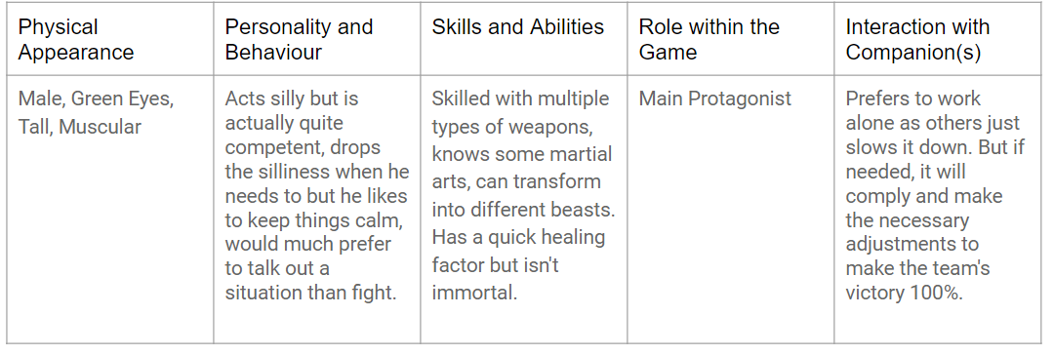As shown on figure 7.1 these were the features chosen by the group members.

Story:

The protagonist of the story is a science experiment made by the government to implement different animal characteristics into the human body.  Through extremely tough training the main character of the story gained an increase in muscle mass.

Figure 7.1 Character Features

Involving brutal experiments, the character gained the ability to transform into different beasts, having the cells of different animal species implemented into his body. Through changing his DNA, scientists managed to increase the average healing power of the human body, making it more efficient and less time consuming.

Unfortunately, the character can experience death as the healing is not happening instantaneously.

As he was a government experiment, scientists wanted to see how this new superhuman would be able to perform in a military action.

So, they hired trainers and military personnel to educate him in the art of war.

Due to the fact, that they had to send him to different locations around the world, he was all by himself. Not having friends or a lover, he grew to trust only himself. So he grew irritated when he had to do a mission with someone else.

After a while he began to show signs of stubbornness and irritation as he saw how different he is from other people, the government was struggling to control him.

Until finally he went rogue and stayed true to himself. Deciding that he should not fight for other people’s entertainment.

Trained in unarmed and armed combat making him a proficient weapon when needed and when these can not be used he relies on his ability to transform into different animals to get the job done.

For stealth tasks turning into a bird then sneaking into a secure building mixed with his hand to hand combat skills made him a valuable government asset.

Reasons:

The team chose this type of character features because they thought that they can come up with a story that will be interesting, action involving and mysterious at the same time. The group looked at a few characters and they chose this one among the others because it looked unique.

Gameplay Mechanic:

The gameplay mechanics that will suit this type of this would be hack and slash type of combat style using a controller or a keyboard and mouse to move the character and fight with enemies. The team agreed on the idea of to put a narrator who can tell stories about the character while the user plays the game, introducing the player to the protagonist. This way the player can feel the game even more and get them involved and compassionate about the character. Using every choice matters type of mechanic would be a good feature to put into the game as it will involve the player to think before they do something as it might affect them in the future, for example if it’s a mission about being stealth and silent, and the player does not cooperate with the mission, their rating among the NPCs in the game will fail and they will give the player an easier mission. Depending on the type of mission the game can have different types of background, but the mood that the game has to have on the user is dark and menacing and they have to be careful about any danger that can come to them.

Created by Rowan Noble, Spas Spasov and Sean Colbourne